**KOPPEL BOROUGH COUNCIL MEETING AGENDA**

Tuesday, May 18, 2023 @ 6 PM Koppel Volunteer Fire Department

**Call to Order**

**Moment of Silence**

**Pledge of Allegiance**

**Approval of Minutes from September 19 and October 3rd**

**Borough Bills from the General Fund**

**Borough Bills for the Fire Dept.**

**Code Enforcement Officer/Emergency Coordinator Report**

**Fire Dept. Report**

**Police Dept. Report**

**Maintenance Report**

**Engineer Report**

**Solicitor Report**

**Mayor Report**

**PUBLIC COMMENTARY**

*Those who desire to address Council during the meeting regarding topics not listed on the Agenda must contact the Borough Office at least 24 hours prior to the meeting so that the topic can be added. Comments made during the meeting should be limited to five minutes.*

**OLD BUSINESS**

* Review Burning Ordinance 373
  + <https://acrobat.adobe.com/link/review?uri=urn:aaid:scds:US:948d5c43-4ee9-3194-ab46-cbb69cc892bc>
* Review enforcement on Brake Retarder Ordinance 402
  + <https://acrobat.adobe.com/link/review?uri=urn:aaid:scds:US:28e25893-4ab5-356f-84a6-f4331b9c1db1>

**UNFINISHED BUSINESS**

* Matt Cesare to present update on his group’s interest in church restoration.
* Emergency demo of 5437 5th Ave. and public nuisance lawsuit.

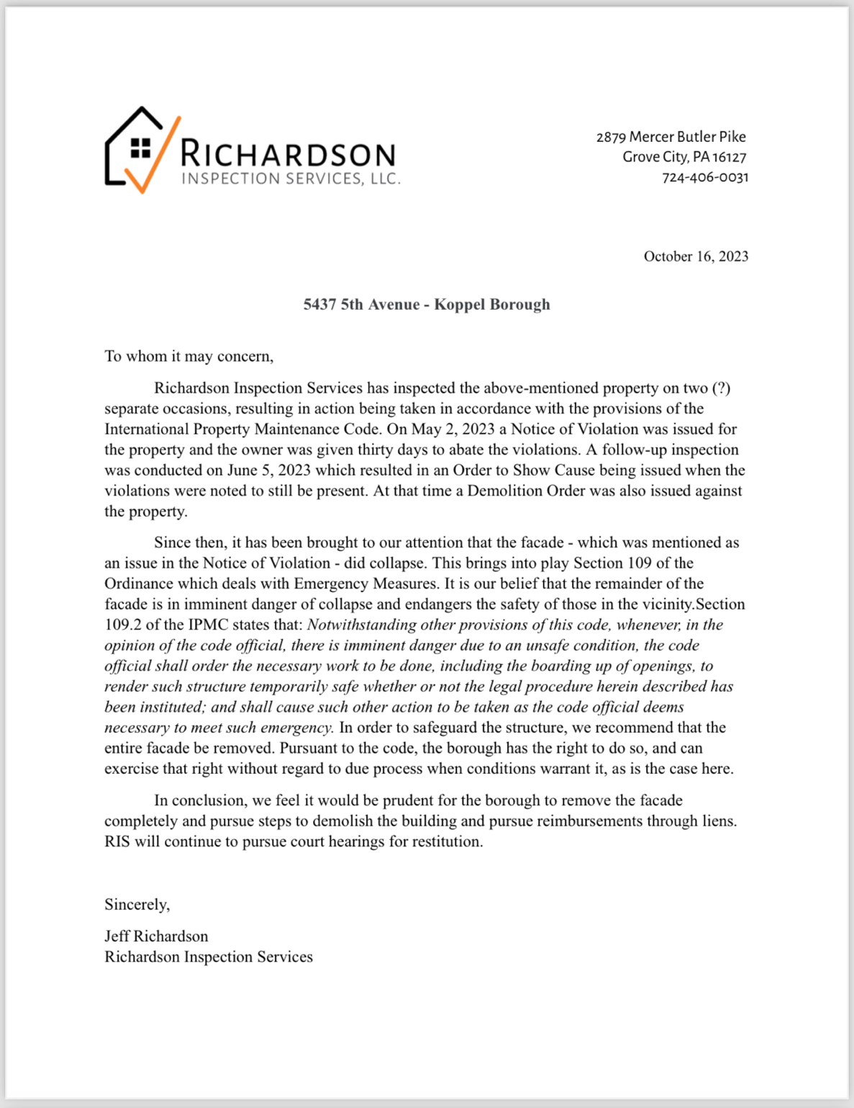

* Council to vote on Uniform Union.
* Completion and advertisement of Basketball Hoop Ordinance.
* Purchase of computer and printer for Tax Collector Office at Borough Building. I’m
* Reminder: Halloween Decorating Contest Judging October 29th. Trick or Treat, Tuesday, October 31st 6–8 PM.

**NEW BUSINESS**

* RFQ for Mary Street from Lindy Paving:

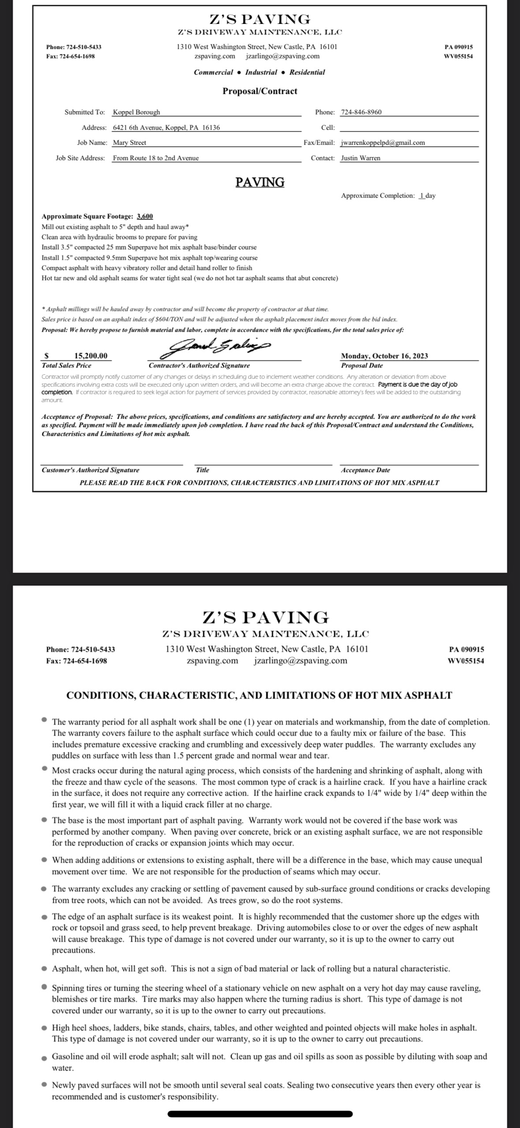

* Purchase of equipment to support TRACS system.
* Jiggy Nardone Memorial Bench/Fund.
* Baden American Legion requesting donation for Veteran’s Day parade.
* Koppel VFD requesting donation for craft fundraiser Oct. 21 and 22.
* DGLVR Training, Center for Dirt and Gravel Road Studies (CDGRS): ESM Training Registration. Vote on cost of travel for mandatory training.
  + <https://dirtandgravel.psu.edu/education-training/esm-course/in-person-esm-trainings/>
* 2024 Tax Ordinance: new calculation based on June closing tax roll and discussion of millage updates for 2024.
  + <https://www.beavercountypa.gov/getmedia/471390be-afae-48fd-88cf-0b58b7fce777/32-Koppel-Boro.pdf>
  + 2023 Tax Rate 20 mills; 2024 proposed millage 6.65–7.32.

**Motion to Adjourn**